**Lewiston-Porter** Central School District

Department of Recreation

“Fitness Center Open to our Community”

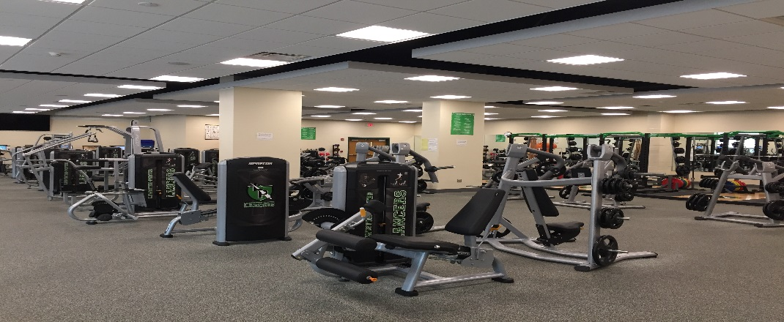

Starting on **Monday, September 9, 2024**, Lewiston-Porter will once again be opening its doors of the Fitness Center to the residents of our district! It is our goal to provide a safe and affordable opportunity to practice a healthy lifestyle. The room is equipped with a variety of cardio, strength, and core training equipment which will be open for students, staff, and community use.

The space is ADA compliant and meets adaptive needs of all users. Equipped with ellipticals, adaptive motion trainers, treadmills, free weight stations, core training stations, strength machines, and virtual reality upright bikes, the workout options are numerous!

The following list of information will allow you the opportunity to plan and prepare for an enjoyable experience. If you have any questions or would like to register, please contact the Director of Recreation, Brad Halgash, by phone: 716-286-7865 or the Athletic Secretary by phone: 716-286-7865 or by email: shoranburg@lew-port.com.

**New Hours of Operation:**

Monday thru Wednesday: 6:00am-7:30am & 5:00pm-8:30pm

Thursday’s: Center Closed

Friday’s: 6:00am-7:30am & 5:00pm-8:30pm & Saturday’s: 8:00am – 11:00am

* Fitness Center will be closed at any time when the district is closed due to holiday/weather.

* This registration is good Monday, September 9, 2024 through Saturday, June 21, 2025.

**General Rules and Information:**

* There will be an adult CPR/AED certified staff member on duty at all times.

* There are small lockers provided for personal items, but no showers.

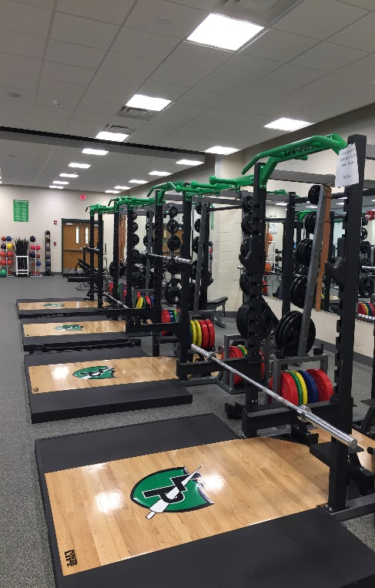* The Fitness Center is open to children 14 yrs. and up.

* We highly encourage all members exercise with a partner.

**Membership Fees:**

* Lewiston-Porter HS students ages 14 yrs. and up - $30.00 per school year

* Adult community members & Lew-Port staff - $80.00 per school year

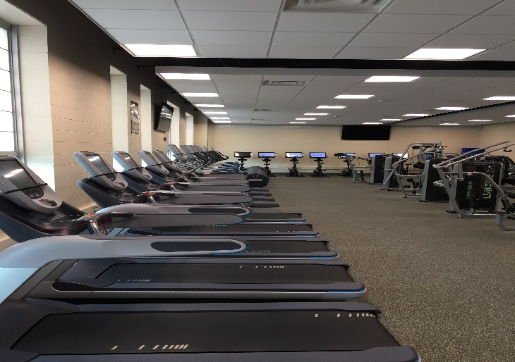 * College Students & Senior Citizens (65+) - $40.00 per school year

